TRUSTEE APLICATION FORM

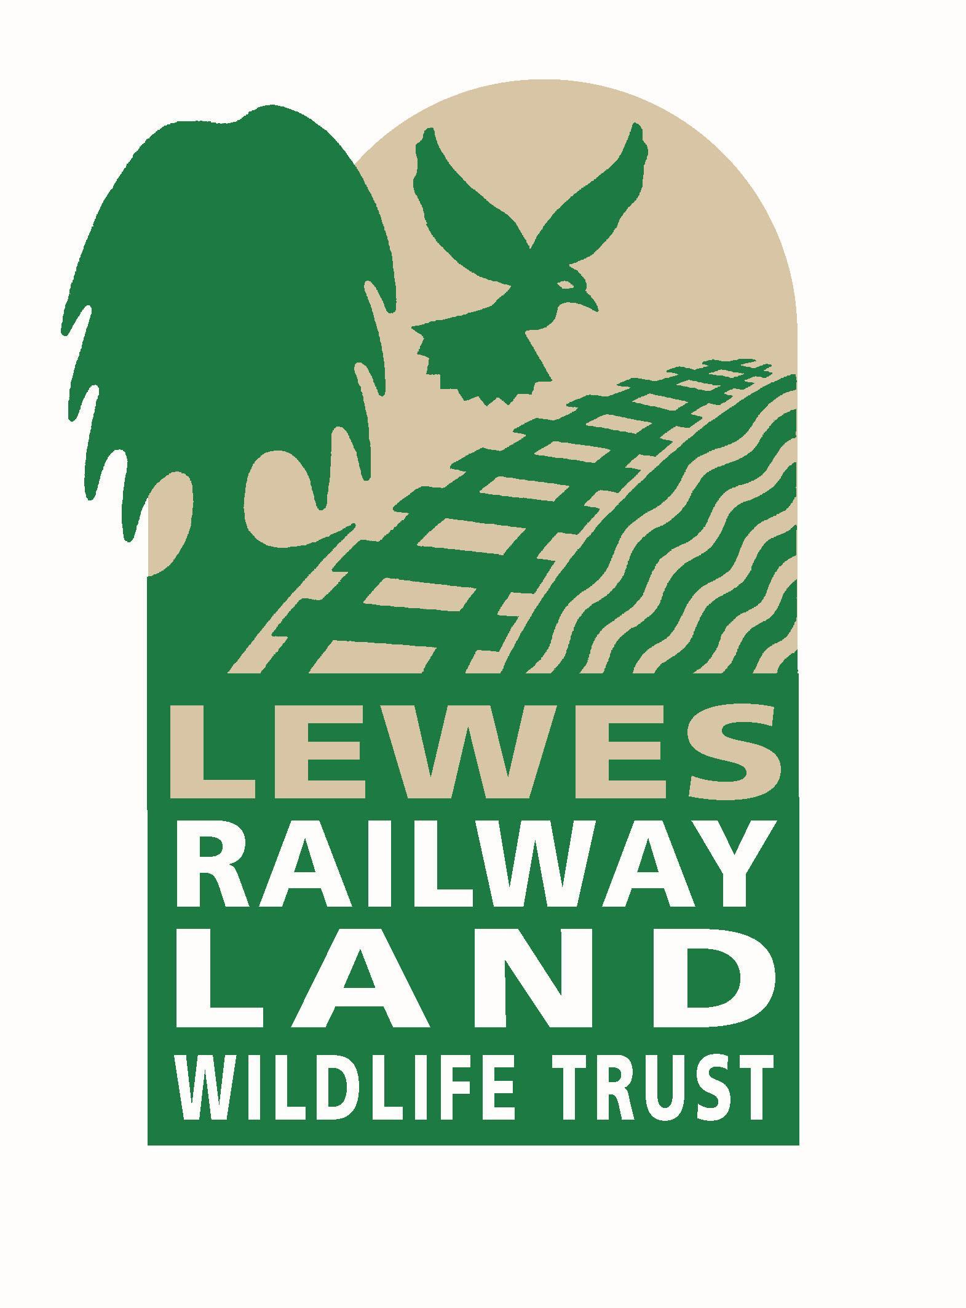
Thank you for your interest in becoming a Trustee of the Railway Land WildlifeTrust.

Please complete this application form and return to helen@railwaylandproject.org

Full Name
Home Address
Telephone Number
Mobile Number
Email address
How did you hear about this opportunity?
Statement of why you would like to be a trustee and what skills and experience you feel you will bring to the RLWT Board

Biographical details
Qualifications
Work History
Voluntary Work
Other charities or environmental initiatives in which you are involved

Thank you for your time in filling in this form. We will be in touch in due course about next steps.

