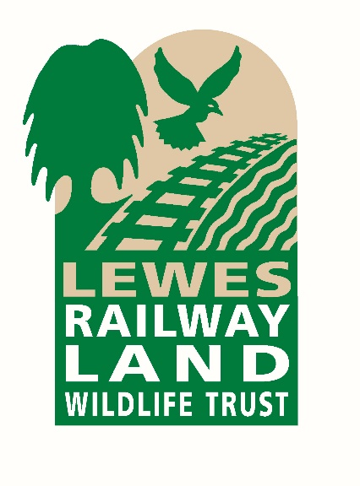

Railway Land Wildlife Trust

Trustee – Chair of the Finance and Support Services Committee

Background to the Railway Land Wildlife Trust (RLWT)

We are an agile charity bringing Nature and Community together – to benefit both. We are based on a local nature reserve in the heart of Lewes with a wonderful Eco-building designed to support life-long learning.

We are a team of eight who collectively deliver and lead our “nature with community” projects; including environmentalists, lifelong learning and community engagement practitioners. We have a cohort of freelancers and an amazing, passionate army of volunteers who embody the role of the community in nature.

Our project work includes practical conservation and habitat creation, young people engagement and support, wildlife discovery, work to support wellbeing, school visits, holiday clubs and much more.

We strive to be bold, with imaginative and inspirational approaches. We are disruptive enough to bring about a culture shift in our relationship with nature and how we link human and natural resilience in the face of climate change challenges.

At our heart is improving the wellbeing of Nature and the Community

For more information about our work, please visit our website www.railwaylandproject.org

Role Description

We know we have a gap on our team and on our board. We want to raise our game in how we use finance and other support services to enable an agile, project-based approach to the work we do.

We are looking for someone to join the senior leadership team and lead on Finance. You do not need to be a qualified accountant; however, it is likely you have been responsible for financial reporting, projects and budgets. We have a bookkeeper; however, financial and project reporting is not automated and leaves a lot of scope for the right person to add a great deal of value. We are a multi-project organisation, each separately funded. This role would Chair the Finance & Support Services Committee and we currently have committee members to cover HR, Legal and IT & Data.

We aim to stay reasonably small and agile, concentrating on developing innovative nature restoration and community engagement. We aim to be a key piece in the jigsaw puzzle of local nature recovery, working collaboratively and in joint ventures with the Local Authority, as well as larger and smaller charities and organisations. We aim to be an exemplar of by making a real and lasting difference to nature and the community.

Key facts: Turnover c£250k, 8 staff including a part time bookkeeper/admin, CEO as well as an active experienced Chair.

Location: Linklater Pavilion, Railway Lane, Lewes BN7 2FG

Commitment: Minimum of 24 days per annum, including quarterly Trustee meetings and regular Finance and Support Services Committee meetings

This is an unpaid role

Main areas of responsibility

- Chair the Finance and Support Services Committee.
- Lead the work that the committee and its members do to enable the charity to deliver on its strategic and operational objectives.
- Work collaboratively with the Chair, CEO and others to develop and evolve the financial and support services strategy
- Ensure that the working practices of the charity are fit for purpose for an organisation this size and be mindful of any charity specific requirements – including Policies and Procedures
- Establish and/or review business and financial controls and work with the CEO to ensure adherence
- Lead the development and production of annual budgets and work with the CEO and Chair on appropriate Project budget and accounting
- Design and produce Management Information and support non-financial trustees to understand financial and other support services
- Review and update reserves policy including clear accounting for restricted reserves
- Work with the charity’s accountants to produce statutory accounts and ensure all statutory filings are made on time
- Support the CEO in overseeing bookkeeping
- Be responsible for bank authorisation of large payments (part of Dual Authorisation and financial controls)
- Ensure we have appropriate oversight of, and support for, the CEO and team in support service including HR, Legal, IT and Data and Facilities Management (FM).
- Work with the Chair to ensure our governance practices are agile and appropriate for the organisation as it disrupts and innovates.
- Work with the CEO and Chair to ensure the risk management process is practical and embedded in working practices

Person Specification

The successful candidate will be an adaptable team player who can give tangible examples of the following skills and experience:
- Working experience of managing finance and support services
- Demonstrate pragmatism in implementing organisational concepts to a small charity
- Willingness and ability to understand and accept their responsibilities and liabilities as a Trustee, and to act in the best interests of the organisation.
- Ability to think creatively and strategically, exercise good, independent judgement and work effectively as a board member.
- Effective communication skills and willingness to participate actively in discussion.
- A strong personal commitment to equity, diversity and inclusion.
- Enthusiasm for our vision and mission.
- Commitment to Nolan’s seven principles of public life: selflessness, integrity, objectivity, accountability, openness, honesty and leadership.

We will also be interested in how and where you engage with nature and your community
For more information about the role of Trustees please see Charity Commission guidance here.
To apply, please download and complete the form that can be found on our Jobs webpage at www.railwaylandproject.org/jobs , and send it to Helen Meade at helen@railwaylandproject.org
Please also contact Helen at this email address if you would like to arrange to have an informal conversation about the role.

